**McDonnell Hall and Brauer Hall Tour Talking Points**

**Black: Academic Information Green: Sustainability/LEED Information**

**1. Hermann Courtyard for Learning**

* Contains water feature, sitting stones, curving pathways
* Native plantings
* Wi-Fi access in all outdoor seating areas around the building
* The trellis will support wisteria plants that will block sunlight and heat in the summer and wither away to allow heat and sunlight into the building in the Fall, Winter and Spring
* Repurposed building materials. Over 90% of the old buildings were diverted from landfills. Materials were repurposed or recycled. Furnishings were donated. Synthetic Slate Shingles made of recycled tires.
* The U-shape design was thought of by students on the planning committee allowing for wider hallway space for easier travel between classes with hangout areas that also allows natural light into classrooms from both sides of the building.
* 18% of the building’s electrical needs are generated on-site with a Solar Thermal system and Photovoltaic system.
* Photovoltaic system: 100kW system 386 PV modules - 8880 SF consisting of (5) arrays = 118,000 kW hr annual electric power generation.
* Solar Thermal panels: 400 SF of collection area. Solar thermal hot water generation is used for domestic hot water and ventilation air pre/re-heat. The hot water is connected to the boiler as a pre-heater.
* 35% of McDonnell Hall and Brauer Hall’s purchased electricity is generated from renewable resources.

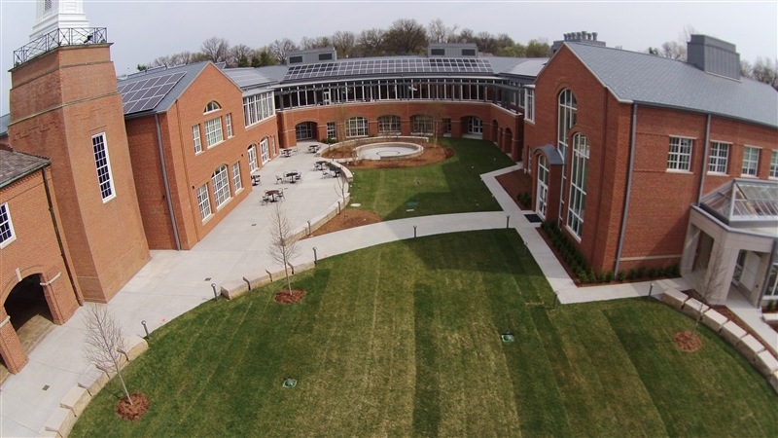

**Additional LEED Information:**

* The building site is a previously developed site, the new facility replaces Danforth and Mathews Hall. The new facility only increases the previously developed building footprint by 1,250 sf , which reduces the impact on undeveloped land and habitats. Demolition of Danforth and Mathews Hall enabled the removal and safe remediation of asbestos that was used in the 1950’s construction.
* Over 90% of building demolition and construction debris was diverted from landfills and recycled.
* Over 35% of the building products include pre-consumer and post-consumer content, reducing the impacts resulting from extraction and processing of virgin materials.
* Over 50% of McDonnell Hall and Brauer Hall’s building materials have been extracted within 500 miles of the site, reducing the impacts resulting from transportation.
* Sheared wool from sheep is a naturally short-cycle renewable material. The installation of wool carpet, cork, rubber flooring, and soy based insulation reduces the depletion of finite raw materials and long- cycle renewable materials.
* 90% of the wood based materials and products are certified in accordance with the forest stewardship council's principle, which promotes environmentally responsible forest management. The standing and running trim is maple and the veneer wood panels are Anigre, an African hardwood.
* Building occupant's comfort and health are protected with the selection of low voc (volatile organic compounds) products including: adhesives and sealants, paints and coatings, flooring systems, and composite wood and agrifiber products.
* A combination of landscape shading and highly reflective concrete reduce the heat islands, which minimizes the impact on human and wildlife habitats.
* Light trespass is minimized as nonemergency interior lighting is programmed to turnoff after hours and exterior lighting fixture housings are full cutoff. Reducing light trespass from the building and site reduces the impact on nocturnal animals and improves night sky access for star gazers.
* Recycling stations are located throughout the building to reduce the hauling and disposal of waste to landfills.
* Post development run-off does not exceed the predevelopment volume. The design limits disruption of the natural hydrology by reducing impervious cover, increasing on-site infiltration, and reduces pollution from stormwater runoff.
* Over 90% of the average annual rainfall is treated with the open vegetation and the bio-retention gardens. Management of the stormwater runoff limits the disruption and pollution of natural water flows to the Deer Creek Watershed. The bio-retention garden treats 5.84 acres of site runoff.
* 8,000 sf of porous concrete parking spaces and open vegetation allow water infiltration into the aquifer while reducing the contaminants and pollutants.
* Native plant selection reduces the need for irrigation by 58%.
* The project boundary encompasses all of the areas disrupted by construction activity.

Over 56% of this area is designated as open space and is 100% vegetated

**Sustainable building materials:**

* Concrete with flyash
* Steel–very high recycled content
* Brick–manufactured locally
* Insulation-Mineral wool (a product of molten rock) and soy based spray foam
* Windows-high performance glazing
* Rubber flooring–low VOC flooring and recycled content
* Wool carpet–rapidly renewable
* Cork–tackable wall surfaces are rapidly renewable
* Synthetic slate shingles–80%post-industrial recycled rubber and plastic

**McDonnell Hall and Brauer Hall Tour Talking Points**

**First Floor**

**2. Brauer Auditorium:**

* sustainable building materials such as Wood and Fabrics, use of light
* Seats 800, holds all US faculty and staff (Lower level: 530 and Balcony: 270)
* Will use a minimum of 2-3 times a week for US assemblies,
* Used for large lectures, grade level meetings, student presentations, guest speakers, and award presentations

**Basic LEED Certification Information**

* Building initially designed for Gold status (60 points). During the building process, it was seen that Platinum level (80 points) might be attainable through design modifications. We will not know final LEED status until building is completed and reviewed.
* Locally sourced Sustainable materials throughout the auditorium, classrooms, labs and offices sourced materials within 500 miles of MICDS: Brick, Paint, Windows minimizing shipping fuel and CO2 released into the atmosphere
* Rapidly Renewable Resources (10 year cycle for harvest) include Wood, Bamboo, Cork, Wool, open and closed cell Soy based spray insulation used throughout the building
* Seeking zero-waste school designation as 75-80% of waste is recycled or composted. Single Stream Recycling throughout the campus.
* Nature motif throughout the building on ceilings, floors and wall panels.

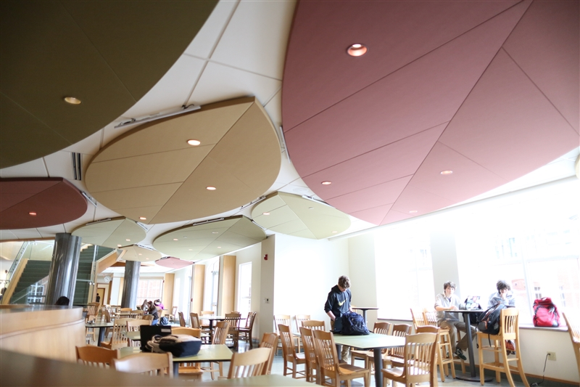

**General Information:**

* Overall Construction 85,500 sf
* New Construction 76,815 sf
* Renovation 8,685 sf
* Science Classrooms 1150 sf average size
* Math Classrooms 800 sf average size
* Greenhouse 600sf + 225 sf mudroom

**Sustainable building materials:**

* Concrete with flyash
* Steel–very high recycled content
* Brick–manufactured locally
* Insulation-Mineral wool (a product of molten rock) and soy based spray foam
* Windows-high performance glazing
* Rubber flooring–low VOC flooring and recycled content
* Wool carpet–rapidly renewable
* Cork–tackable wall surfaces are rapidly renewable
* Synthetic slate shingles–80%post-industrial recycled rubber and plastic

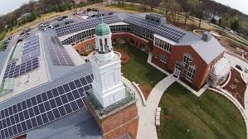**Bob Shaw**

JK-12 Science Department Chair

Director of Environmental Sustainability

314-997-7459 x.7569

[rshaw@micds.org](mailto:rshaw@micds.org)

[robotics@micds.org](mailto:robotics@micds.org) (robotics events)

[www.micds.org](http://www.micds.org)

**McDonnell Hall and Brauer Hall Tour Talking Points**

**3. Commons**

**Taylor Family Hearth Area**

* Community gathering space, very much like a living room with comfortable furniture and a fireplace! Soft places to read, rest, reflect and hang out with friends.

**Outdoor Patio**

* Comfortable outdoor gathering space for students/teachers with Adirondack chairs. Bands can play to crowds in Danforth Square, outdoor assembly space.

**Holekamp Study COMMONS**

* Comfortable, causal study area for students, meeting space
* Tables of various heights like airport with lots of outlets!
* Hard surfaces for writing, using electronics and meeting with friends.
* The natural plant materials in the resin panels include: wheat, violet, birch, leaves, and woodland ferns.

**4. Tech Support Area**

* MICDS has a 1:1 laptop program in grades 5-12
* A support counter for students and faculty staffed with a fulltime professional and several student volunteers
* Safe and ample storage for technology equipment (helps put the T in STEM)
* Furnished student waiting area across from the helpdesk
* An interactive building Dashboard tracks energy and water production and consumption as well as the weather.
* Water bottle filling stations are located at every drinking fountain. Each station monitors the number of water bottles filled at each location.

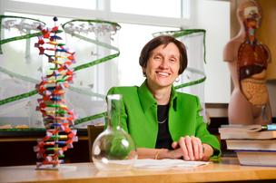

**Becky Young**

MICDS Chief Financial Officer

*2014 Small Nonprofit CEO of the Year -STL Business Journal

**McDonnell Hall and Brauer Hall Tour Talking Points**

**5. O’Hara Family Research Lab**

* Space for long-term experiments and projects with practicing scientists
* Supports the long-term exploration of STEM topics
* Flexible space, used year round, movable benches
* High speed computers will be used for processing data and graphic capabilities for research in mathematics and chemistry using Odyssey and Spartan software as well as programming functions.
* Yeast research in collaboration with Monsanto
* DNA research in collaboration with Danforth Plant Science Center
* Support for Zebra fish/collaboration with Washington University School of Medicine
* Computrainers for collecting data in math/science and cycling team

Courses Offered:

**501: Research Methods in Biology**

This one-trimester course introduces students to common molecular and cellular biology techniques, DNA sequence analysis, and bioinformatics. Using these techniques, students will create molecular and computational tools that can be used to study the effects of specific genes on living organisms. During this course, students will learn how and why scientists use simple organisms to model and study complex biological processes and how computer programming and statistics can be used to organize, compare, and manipulate large sets of data. After taking this course, students will be eligible to take a two-trimester independent research course, in which they will be mentored by a faculty member as they test their own hypotheses.

*Prerequisites: Cells & Genetics and Atomic Structure & Reaction Quantities or Science 10, Integrated Mathematics 1, and Departmental Approval*

**502: Independent Lab Research**

A two-trimester independent research course in which students will be mentored by a faculty member or visiting scientist as they develop and test their own hypotheses. Techniques learned in the *Research Methods in Biology* course will be used to conduct experiments agreed upon between the student and mentor. Students will be required to keep a detailed lab notebook to document their data, write a formal article to report their findings, and present their project in a public forum.

*Prerequisites: Research Methods in Biology and Department Approval*

**650: Advanced Science Tutorial**

Students may earn an Applied Science Topic credit for their involvement in an on-going collaboration with a practicing scientist or research institution. Students must have a faculty sponsor/mentor, document their work schedule, provide contact information to their *Advanced Science Tutorial* supervisor, and provide a paper within thirty days after the experience outlining roles and responsibilities as well as the purpose of the collaboration and knowledge gained from the experience. Students will be assessed using a Pass/No Pass grading standard.

**Other Classes Offered on this hallway on next page:**

**600: AP Biology**

This is a college level course that covers a broad spectrum of biological topics including cell biology, biochemistry, genetics, evolution, anatomy and physiology, botany, and ecology. The syllabus is approved by The College Board. Labs are performed to reinforce these concepts. The class is designed to make students successful on the required AP exam given by The College Board in May. Students are required to do summer work prior to the course.

**602: AP Environmental Science / 400: Environmental Science**

This course is designed as the equivalent of a 1-semester college course. Students are introduced to the fields (biology, geography, sociology, economics, natural resource management, chemistry, geology, law, and politics) used in understanding both the workings of and human interactions with our environment. The syllabus is approved by The College Board and the course is designed to make students successful on the AP exam given by The College Board in May. Topics include: human population growth, energy resources, land and food resources, water resources, air pollution, global climate change, and human health and toxicology, as well as a review of ecology and species diversity. Sustainability is a unifying theme throughout the course, as is an understanding of the linkages between ecosystems. This understanding gives students a greater appreciation for and better stewardship of the world in which they live.

**301: Animal Behavior**

In this course, students learn about the basics of behavior and methods of animal research. They explore behaviors that are used for: communication, navigation, reproduction and parental care, foraging, learning, and social bonding. They learn about the proximate and ultimate causes of behavior, examine the costs and benefits of behavior, and put the idea of behavior into an evolutionary context. The course has an extensive laboratory component, including investigations of live animals, as well as video and audio recordings of behavior. A representative from the St. Louis Zoo Outreach Program will give a presentation on animal research to the students. All students are required to make observations of animals at the zoo outside of class time.

**302: Anatomy and Physiology**

This is a laboratory-based course where students will generate knowledge about anatomy (structure) and physiology (function). Students will actively construct, acquire, generate, and share knowledge through interaction with each other, written text (books, magazines, newspapers, pamphlets and on-line resources), graphs and data charts, dissections, drawings, pictures and movies, sound, microscopes, test tubes, and specimens. At the end of the course, students will be able to identify major structures of the human body by location and/or observation, use anatomical terminology with facility, and develop a high regard for the beauty and efficacy of the human body.

**307: Neuroscience**

In this course, emphasis is placed on the physiology of the brain (particularly the cerebrum) and on how our brain affects our behavior. Through labs, demonstrations and open-ended inquiry, students explore the sensory and perceptual functions of vision, hearing, balance, taste, touch, and smell. They examine how the brain regulates memory and learning, personality and emotions, and sleep. They learn how a healthy brain functions and examines the consequences when something goes wrong. Students have the opportunity to design and carry out an experiment based either in psychology or physiology and to present their results to the class.

**230: Kinesiology**

This course studies the analysis of human movement based on anatomical and mechanical principles. Emphasis is given to the application of these principles, to the understanding of human movement and physical performance. Concepts related to Sports Medicine, sport performance, and related science is covered in this course.

**460: Forensics**

Forensic science is a significant part of solving crimes. This course emphasizes the methods of observing, gathering, and analyzing physical evidence to solve mysteries and to challenge the student's critical thinking and problem solving skills. While there are hundreds of methods currently used in forensic laboratories, this course focuses on the use of biology, chemistry, and biotechnical sciences as sources of useful tools in forensic analysis. Students discuss the merits of the evidence they collect. Structured hands-on activities and small group projects make this an active course.

**McDonnell Hall and Brauer Hall Tour Talking Points**

**6. Plant Science Research Classroom Laboratory & Greenhouse**

* Environmental Studies, Biology electives: Animal Behavior, Neuroscience, Botany, etc.
* Greenhouse designed w/consultation from Danforth Plant Science Center & Monsanto greenhouse experts
* Ample prep area with access to the outdoor classroom
* Greenhouse cooling system uses water from water harvesting storage tank
* Access to the GH from classroom and the outside.
* Greenhouse is 600sf + 225sf mudroom
* 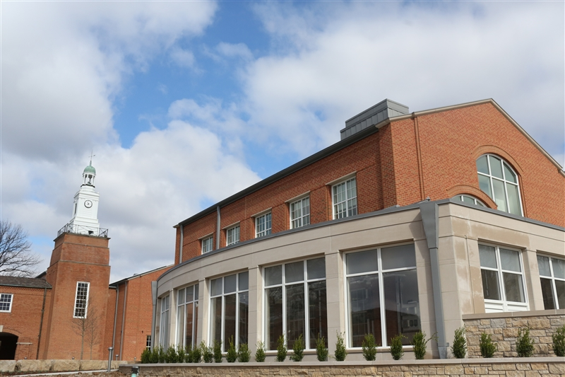6th grade students will use the greenhouse to grow native plants from seeds harvested on campus and will be planted near the creek where students removed an invasive Honeysuckle species.

**Courses Offered:**

**303: Genetics and Biotechnology**

She has her father’s eyes! He has his mother’s nose! Drought resistant plants are the answer to starvation in Africa! All of these statements have something to do with the genetics of organisms. This course focuses on a gaining deeper understanding of genetics using biotechnology. We will discuss personal genetic topics as well as current issues like GMO’s.

**308: Marine Biology**

This course is designed as a survey of the marine environment and its inhabitants. Students are introduced to ecological concepts and a wide range of marine organisms, as well as relevant conservation issues, all within a framework of marine habitats: coral reefs, kelp forests, seagrass beds, rocky coastlines, the deep sea floor, and the open ocean. The course’s laboratory component involves several dissections, as well as investigations of some of the physical components of the ocean, and examinations of adaptations of marine organisms to their habitats. Students take from the course knowledge of the interconnection between diverse ocean habitats and an understanding of threats facing the world’s oceans.

**310: Botany**

This course is designed as a survey of plants and their biology, threats, defenses, and uses. Students will be introduced to ecological concepts and a wide range of plants, as well as relevant conservation issues, all within a framework of terrestrial habitats: tropical rainforests, temperate grasslands, and coniferous forests. The course’s laboratory component involves many field investigations, as well as explorations of the evolution of different plant families and the structure and function of leaves, roots, and stems. Students investigate the adaptations of plants to their habitats. Students will take from the course knowledge of the interconnection between diverse plant types and an understanding of the importance of preserving the integrity of the world’s forests and grasslands.

**McDonnell Hall and Brauer Hall Tour Talking Points**

**7. Outdoor Teaching Garden**

* Open and available to the community of dog walkers and joggers
* Jk-12 space for all disciplines featuring an outdoor classroom
* Native and orchard plantings with interpretive signage
* Interpretive signage will have QR codes describing features (installed this summer)
* Bio-swale captures all rainwater from our perforated parking lot
* Data collection for Deer Creek Water Shed and MO Stream Team will be done here
* Permeable surfaces allow for surface water to soak in through pavement in parking areas. It is also cooler and reduces the heat island effect.
* Over 50% of the project boundary disturbed by construction has been restored as open green space. This also greatly reduces the need to irrigate by planning native species such as Dogwood, Maple and Oak trees, Juniper, Azalea, Bluestars, Yarrow, and Prairie Drop Seed plants and eliminates weekly mowing in these areas

**More to Come:**

* Bike racks and designated routes to Ladue Road and Lindberg Avenue will be provided to promote alternate transportation and reduce the dependence on cars and vehicular emissions
* Preferred parking will be provided within the north parking lot for Hybrids and Electric cars
* Signage identifying plants and educational areas will be located in the outdoor classroom

## Awards and Recognition



**U.S. Green Building Council Growing Green Award**

MICDS won the 2014 Growing Green Award by the USGBC-Missouri Gateway Chapter for its STEM curriculum and for building the most advanced STEM teaching facility in the region.

Integrated Education in Site Design

A key design component of the site and landscape surrounding the math and science building was to create an integral link with the curriculum of MICDS. The site features are intended to facilitate the educational goals of the school and provide elements that promote learning and understanding of the natural environment, native plant communities, and wildlife habitats. Many of these elements serve as educational opportunities to the public as well as the students and faculty of MICDS.

The courtyard within the building provides an outdoor classroom surrounded by native vegetation and natural arboretum. The balconies that overlook the courtyard will also allow for a wide variety of pendulum and physics drop activities. The space provides a launching point for outdoor based learning opportunities as well as a comfortable gathering space for site users. At the entrance to the courtyard is a garden tailored to providing food and habitat to native bird (purple martin colony) and butterfly species affording opportunities for bird and bird song identification from a bird blind as well as edible and medicinal plant education and connections to butterfly migration tracking and species release in the garden.

Moving out from the courtyard the building is surrounded by native plantings with species representing a number of regional plant communities. These areas are linked by a serpentine walk, which provides easy access to all the educational opportunities within a few minutes’ walk from the classrooms of the building. The serpentine walk around the building ties the courtyard and adjacent educational spaces to an accessible loop walk that extends into the generous green space located between the new facility and the adjacent public right of way along Warson road. These elements allow integration of the exterior environment into classroom curricula.

These elements located at the “front door” of the campus are designed to provide a showcase of sustainable design features and serve as teaching tools to all. Features include a rain garden, boardwalk, drystream and bioswale, native plantings, an orchard, and an outdoor classroom seating area.

A large rain garden is the centerpiece for this space and provides water treatment for the adjacent parking lot and new building. Native plantings within and around the rain garden provide habitat to local wildlife while offering a unique teaching tool, which facilitates learning about natural systems, wildlife, and sustainable design. A Water Chemistry course as well as our the MICDS Stream Team will monitor the water quality of all standing water on campus and present and share the data with the community, including the Deer Creek Watershed, Missouri Department of Conservation and World Water Monitoring Day.

The accessible walk leading from the courtyard to the rain garden connects to a boardwalk which spans the drystream and bioswale; then continues on to span across the rain garden; allowing users to engage these features where students can down and look for animal tracks in the soil, sand, silt and clay or study the geology of native rocks and minerals or be elevated to eye level with the canopy of short tree species along the path/boardwalk. MS students will be able to visit to see these erosion control demonstration and treatments. Signage will tell the story of long before urbanization, the front lawn of more recent years and the re-naturalization of the area as part of the construction project, thus demonstrating the School’s commitment to Sustainability. Benches and ledges will be built into along the path, so students (and visitors) are encouraged to pause for a mini-lesson or reflect on the beauty of the natural world.

**McDonnell Hall and Brauer Hall Tour Talking Points**

**8. Lower Level: Severe Weather Safety Area**

* Hallway holds up 800+ people, equipped with emergency supplies and restrooms

**Rainwater Harvest**

* 10,000 gallon tank is buried in the courtyard and captures rainwater from the building roofs which is used to flush toilets and for the greenhouse evaporative cooling system – effectively reducing the overall demand for potable water sewage conveyance by 76%. Captured rainwater is filtered with UV light for re-use.
* Low flow toilet room fixtures and captured rainwater reduces the demand for potable water usage by 64%.
* The kitchen equipment, the laboratory sink faucets, the laboratory ice machines, and the greenhouse evaporative pad all use less water than standard equipment, reducing water consumption.
* 10,000 gallon rainwater storage + 1100 gallon day tank
* This system will reduce the use of treated public water for waste purposes
* Water data is collected and used in science and mathematics courses

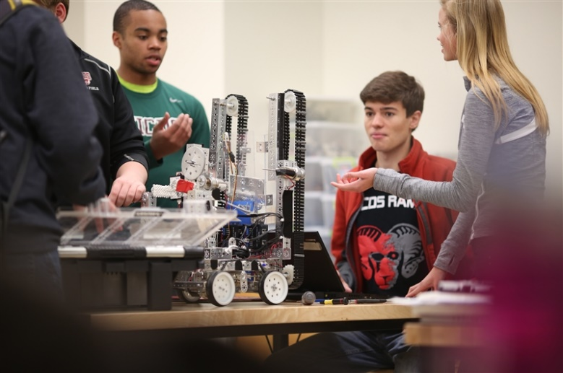**Robotics Lab**

* For-credit courses and extracurricular robotics club in MS and US meet here.
* Includes a 3D printer, tool bench and tool room as well as breakout spaces
* Applications for the arts

**240: Electronics and Robotics Course**

This class will produce a robot to participate in challenges for the contemporaneous school year. Students will design, build, and program a robot to play a game whose rules will be announced shortly after the beginning of the class. The robots will then be used in competitions. Students will learn engineering principles, construction techniques, and Robot C programming language. Culminating project:  Using the engineering design process, students will design and construct an autonomous robot that can navigate a course and manipulate an object in a disaster response scenario.  Each robot will use sensors and a manipulator arm to seek out the "victim" (doll), retrieve the victim, and return the victim to a designated area.

**250: Maker: Digital Design and 3-D Modeling Course**

Digital fabrication uses principles of design and a variety of software and electronics packages to translate a 2-D or 3-D design into a physical object made of wood, plastic, cardstock, or metal. Students will incorporate principles of programming with the arduino to add interactivity to their design. Students will use special equipment including a 3-D printer to bring their designs to fruition. This course is project based and hands-on. Using the engineering design process, students will participate in a competition to design and build a battery-powered vehicle out of 3D printed parts that will compete for both the fastest speed and the furthest distance that it can climb on a 30 degree ramp

**McDonnell Hall and Brauer Hall Tour Talking Points**

**Second Floor**

**9. Math Lecture Hall**

* Partition that is movable will have dry erase boards on both sides
* With partition open, room can be used for multiple sections of a class or grade level
* Very useful for AP classes, guest lecturers and STEM activities
* Plenty of room for hands-on activities
* Already booked for two conferences this summer: Deer Creek Water Shed Annual Meeting and Sustainability Institute for K-12 Educators.

**ELIOT SUMMER ACADEMY COURSE OFFERINGS**

**2014**

Number Theory: Math in the Digital World

Advanced Science Tutorial  
Anatomy and Physiology

Astrophysics

Digital Design and 3-D Modeling

Health

Kinematics and Dynamics

Marine Biology

Neuroscience

Research Methods in Biology

**2015**

Linear Algebra

Number Theory: Math in the Digital World

Advanced Science Tutorial

Anatomy and Physiology  
Animal Behavior

Botany

Digital Design and 3-D Modeling

Research Methods in Biology

**STEM / Maker Camp for Middle School Students**

**All Mathematics Course Offered**

**100: Algebra: Foundations for Integrated Mathematics**

**200: Integrated Mathematics 1**

**250: Integrated Mathematics 1 Accelerated**

**300: Integrated Mathematics 2**

**310, 311, 312: Integrated Mathematics 2: With Application (Recommended Course)**

**350: Integrated Mathematics 2 Accelerated**

**380: Problem Solving: Mathematical Minds**

**390: Number Theory: Math in the Digital World**

**403: Financial Algebra**

**405: Interdisciplinary Statistics: Ecology and Environmental Science**

**406: Linear Algebra**

**410: Mathematical Modeling and Trigonometry**

**420: Applied Math: Math and Multi-Media**

**425: Modeling with Technology**

**430: Analytic Geometry**

**450: Discrete Mathematics**

**520: Calculus**

**600: AP Statistics**

**601: AP AB Calculus**

**602: AP BC Calculus**

**650: Multivariable Calculus**

**320: The Programming Environment**

**325: Advanced Data Structures**

**603: AP Computer Science**

**10. Classrooms**

Science and Math classrooms have a group meeting location and lab section. The labs have different features depending on the type of activities that take place in these locations (breakout meetings, chemistry, physics, microscope use, or several of these combined activities). Science preparation rooms nearby allow teachers to prepare for classes. These rooms have storage, dishwashers, ice machines, natural gas ports, and counter space to prepare lab activities and investigations.

**Science 10 (Chemistry and Biology STEM) Classroom Lab**

* + Large and flexible– combining instructional space and laboratory space so students and faculty can go back and forth as needed
  + Can leave long-term experiments up for extended periods of time
  + Allows the delivery of the curriculum developed with a focus on hands-on, inquiry-based learning
  + 200: Science 10: Chemical and Life Processes
  + 311: Chemistry of the Environment
  + 601: AP Chemistry

**Science 10 –** What is STEM?

When using the STEM Method, we aren't just adding math, engineering and tech to a science class.  We have been especially thoughtful to find assignments/activities, labs and project that all have a basis in REAL life, a real world application.  For example, we didn't want to do the same labs where we teach kids about the 4 biological macromolecules (lipids, proteins, carbohydrates, nucleic acids) as in the past.  It is important content, but we wanted to give it context. So we are doing a two part lab as one of our first lab activities in the first unit;   first students work in teams to develop the standards for some common and general macromolecule tests (using indicators to determine both a positive and negative result for a particular molecule) and sharing with other groups to create one larger common table they all helped create.  However, the REASON they learn to test for the molecules is because there has been a crime committed where an individual was poisoned, and they need to test the sample of stomach fluid (or vomit!) to determine the victim’s last meal, which would determine which restaurant he ate and which suspects we have in the crime. If they ran the standards properly, and all shared valid data, they should all be able to accurately identify which macromolecules were in his last meal, allowing us to determine if he last ate steak, or rice and beans, or ice cream!

This added context, although sometimes silly, is always tied to a real-world reason **to learn content, to follow scientific method, to design experiments and use engineering principles, to apply mathematics, to apply technology, to share data**. It is not about learning content to get through the content, then regurgitate content back in a test.

We are doing similar activities when teaching about types of reactions and stoichiometry/limiting reactants (we have a "fizzy drink" lab, where they determine why and how we determine the proper amounts of substances that need to be added to carbonated drinks, to reach proper carbonation levels and taste good). We are going through another lab with the accelerated math students where we model the entire process of extracting aspirin from Willow tree bark.  This includes the history of how we figured this out from stories of Native Americans that used to chew on the bark from small branches to reduce pain.

After finishing energy and redox reactions, students will work to build a small model car that runs on a simple chemical reaction of water (the Hydrogen Fuel Cell), and we hope later in the class when teaching photosynthesis to compare this energy source to Solar Cells and show how energy comes from multiple sources.  Then going toward the Cellulosic Biomass conversion to Ethanol Fuel.  Kids do more than just learn that fermentation produces ethanol or that ethanol can be used for fuel, the NEED the biochemistry they learn in the first three units to determine why it isn't a simple matter to break down cellulose (one of the 4 macromolecules we study earlier), why we need enzymes, why different chemical bonds respond in different manners....on and on.

There is always something new and exciting, tying many various areas of the course together.  Gone are the days of "first we teach chemistry, then biology, then energy, then evolution".  Now we are continuing to build and tie in lots of areas.

**Physics Classroom Laboratory “Clab”**

* + AP Physics C: Mechanics, AP Physics C: Electricity and Magnetism and stand-alone physics courses in this room.
  + Black out shades for light and lens investigations
  + Everything is movable and this makes this room very flexible
  + Close proximity to math classroom, can use and share real data and equipment
  + 315: Physics of Sound and Light
  + 320: Astrophysics
  + 324: Astronomy
  + 611: AP Physics C: Mechanics
  + 612: AP Physics C: Electricity and Magnetism

**Mathematics Classrooms**

* + 800 square feet
  + Layout of the room offers opportunities for differentiated instruction
  + Break out areas for small group work
  + Can write on the walls! Exciting feature for students…and teachers!

The building’s performs 55% more efficiently than the code required performance standards. This significantly reduces the environmental and economic impacts of excessive energy use.

Energy reduction strategies include:

* VRF mechanical system – Variable Refrigerant Flow is a highly efficient HVAC technology that allows for on demand heating and cooling within rooms. Traditional systems heat or cool the entire building; this technology allows heating and cooling as needed by space.
* Ceiling Fans - The classroom ceilings ‘float’ and allow for even distribution of heating and cooling at the perimeter of the rooms. While the high volume low speed ceiling fan draws the air across the space, returning above the ceiling.
* Carbon dioxide sensors - Co2 sensors in each classroom detect when the space is occupied and when fresh outside air is required. When classrooms are unoccupied the mechanical units turn down to reduce energy consumption.
* Highly insulated building envelope-the roof and walls of the building are comprised of two types of insulation and high performance glazing to minimize heat loss or heat gain, reducing the size of the mechanical system requirements.
* Daylight-Access to daylight reduces the need for electric lighting.
* Daylight Harvesting - Sensors in the high efficiency light fixtures determine the room light levels allowing the fixtures to dim down or turn off when there is adequate natural light. Classrooms are typically designed for 50 foot candles.

**McDonnell Hall and Brauer Hall Tour Talking Points**

**11. Faculty Work Center**

* Place for all math and science faculty to work and plan, increasing collaboration
* Most efficient use of classroom space – Equipping each classroom for coursework, not a specific teacher provides more flexible use of the building
* Renewable wood used for all furnishings: Kewanee
* Makes faculty more accessible to students get help if needed
* Great space to honor the value of teachers in a comfortable and useful area
* Fireplace, coffee station, terrace, skylights – very nicely appointed work area!
* Dean offices and conference room located across the hallway and directly below.
* There are 3 science preparation rooms where teachers can go to prepare for classes near their classrooms. These rooms have storage, dishwashers, ice machines, natural gas ports, and counter space to prepare lab activities and investigations.
* Each classroom area has a prep room, so teachers can safely store equipment and prepare activities and labs near the classrooms
* Executive Conference Room seats 20+ participants

**Department philosophies and graduation requirements for students entering next year**

**MATHEMATICS**

The Upper School Mathematics program models and encourages the attitudes and skills that allow for the growth of confident, capable, and independent learners. Through partnership with student, parent, teacher, and School, the Department supports our students in their development of an ability to think critically, creatively, and strategically and an awareness of how mathematics integrates with other disciplines. Math lessons are designed to encourage students to seek out and enjoy mathematical challenges and to discover an appreciation for the power, wonder, and meaning of mathematics. As students progress through the course sequence, they further their understanding of numbers, patterns, functions, and relationships.

**For Classes 2015, 2016, 2017:**

* Students are required to complete eight trimesters of mathematics which must include the *Integrated Mathematics* or *Integrated Mathematics Accelerated* sequence in its entirety.

TOTAL REQUIRED: 8 trimesters

**SCIENCE**

The MICDS Science Department’s primary mission is to provide a foundation of excellence in the study of science for all students. Students engage in the study of science through the acquisition, exploration and demonstration of science, technology, engineering, and mathematics (STEM) skills and content knowledge through developmentally appropriate curriculum. Whether as scientists or scientifically literate citizens, MICDS graduates must be prepared to enter a world of increasing scientific and technological complexity.

**For Classes 2015, 2016:**

* Students are required to complete one trimester of *Health* and eight trimesters of science: six Core Science trimesters and two trimesters of Applied Science Topics courses.

TOTAL REQUIRED: 8 trimesters & 1 trimester of *Health*

**McDonnell Hall and Brauer Hall Tour Talking Points**

**12. Ninth Grade Math-Science cluster**

* Math and Science integration allows for intentionally shared curriculum & projects
* Ninth grade math-science workspace and project layout tables outside the Science 9 rooms allows for students to access materials and tools for math, engineering and science curriculum projects.
* This close proximity between freshman math, science and faculty offices allows for strong integration among the curricula and sharing equipment among courses.
* Remodeled portion of the project allowed Founders Court to remain and afford spectacular view of both the newest portions of campus and the historic and storied areas such as Smen Pond and other buildings.

**Courses Offered**

**100: Science 9: Matter, Energy, & Interactions**

This course explores concepts of science, technology, engineering, and mathematics through concepts of matter, energy, and forces. Matter has structure and its components interact. Energy links matter to gravitational, electromagnetic, and nuclear forces in the universe. Science 9 also addresses the conservation of mass and energy, momentum and charge. Attendance will be required at one presentation outside of class each trimester.

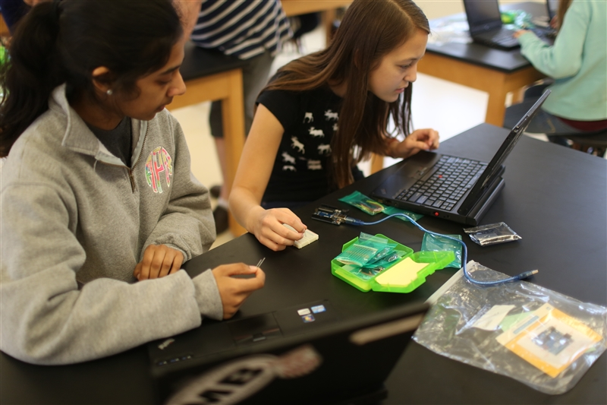**Science 9** –from a student

I think our Arduino project was an excellent assignment.  Sometimes it is hard to describe an Arduino.  Here is how I like to do it ... An Arduino is small physical computing platform about the size of a deck of cards that uses a simple microcontroller board onto which a variety of sensors and devices may be wired and controlled.  It is coupled with an integrated development environment for writing the software that controls the board itself.  The project we were given was very open ended ... sense some data from the environment and do something with that information.  The code that controlled their circuit needed to have logic in it and make decisions based on the data obtained from the sensor.  As students, we were free to pick projects and used the internet to guide/direct them.  Projects ranged from sensing the temperature every 5 seconds and flashing a series of different colored lights for temperatures in specific ranges, to sensing the temperature and turning on small fan if the temperature was too high, to sensing the humidity of a soil sample and flashing lights if the sample was too dry, to using a motion sensor to tell a teacher how many students had entered a room, etc.

**All Science Courses Offered**

**100: Science 9: Chemical and Physical Systems**

**200: Science 10: Bio-Chemical Applications**

**221: Kinematics and Dynamics**

**400: Environmental Science**

**230: Kinesiology**

**240: Electronics and Robotics**

**250: Maker: Digital Design and 3-D Modeling**

**301: Animal Behavior**

**302: Anatomy and Physiology**

**303: Genetics and Biotechnology**

**307: Neuroscience**

**308: Marine Biology**

**310: Botany**

**311: Chemistry of the Environment**

**315: Physics of Sound and Light**

**320: Astrophysics**

**324: Astronomy**

**40: Forensics**

**501: Research Methods in Biology**

**502: Independent Lab Research**

**600: AP Biology**

**601: AP Chemistry**

**602: AP Environmental Science**

**611: AP Physics C: Mechanics**

**612: AP Physics C: Electricity and Magnetism**

**650: Advanced Science Tutorial**

As part of our JK-12 Science program, we have focused on the grades 5-10 sequence and are rolling out courses more aligned to STEM disciplines, NGSS standards and collaboration with local science and education institutions. Here are some highlights:

5th grade: Physical and Earth Science (2011): LEGO Robotics unit

6th grade: Ecology (2013): small maker projects with solar ovens and 3D printing

8th grade (2015): Intro to Physics and Chemistry: CO2 car with student designed 3D wheels.

9th grade Physical and Chemical Systems (2013): students build and program Arduino kits to collect environmental data and do something with the data (communicate or actuate). These are used in a high altitude balloon project.

10th grade Bio-Chemical Applications (2014): Using Chemistry topics to more deeply understand Biology content has allowed students to dive more deeply in to the content. A high altitude balloon launch will collect data to be used in this course.

Robotics (2012): Trimester course where students design, build and program robots to accomplish several tasks.

Maker Science (2014): Trimester course where technology-based engineering-oriented pursuits such as electronics, robotics, 3-D printing, and the use of CNC tools are used by students to address large and small scale problems.

Research (2014): Three single trimester courses are available for students to take in sequence:

1) Research Methods in Biology: Students use of tools, read primary research documents and develop shared protocol for research

2) Independent Lab Research students develop independent research and work with science faculty mentor and communicate results through publication and through science outlets.

3) Advanced Science Tutorial: students develop or continue research protocols with the supervision of science faculty mentor and/or practicing research scientist. Typically in a partnership with local science institution.

The STEM building opened in March 2014 which includes 10 science labs. Classrooms are set up to have classroom and lab space as well as connections to preparation rooms and storage. Longer periods (90 minutes) helps with our project-based approach.

We have a dedicated robotics space and will open a dedicated Maker space in 2015. These spaces have 3D printers, CNC Mill, several garage-style tools, tables and storage. The collaboration with Stratostar high altitude balloon launch is new this year and will launch in April 2015.